

|  |  |
| --- | --- |
| **IDS 462 STATISTICAL SOFTWARE FOR BUSINESS** | |
| **HOMEWORK 3 – Part 1** | |
|  | **TEAM MEMBERS**: |
| 1. | Harish Visweswaraiya |
| 2. | Sriram Ravi |
| 3. | Vinodh Sankaran |
| 4. | Balachandhar Chekka Narayanasame |

Problem 1.4 - SAS program for IQ calculation

a) Create variables OVERALL and GROUP

Input 001128550590 002102490501 003140670690 004115510510

Code /*Part A*/

data iq_and_test_scores; input ID 1-3

IQ 4-6 MATH 7-9

SCIENCE 10-12;

OVERALL = ((IQ+MATH+SCIENCE)/500); If IQ<=100 then GROUP = 1;

Else if IQ<=140 then GROUP = 2; Else /*if IQ>140 then */ GROUP = 3;

Datalines;

001128550590

002102490501

003140670690

004115510510

;

Output Data

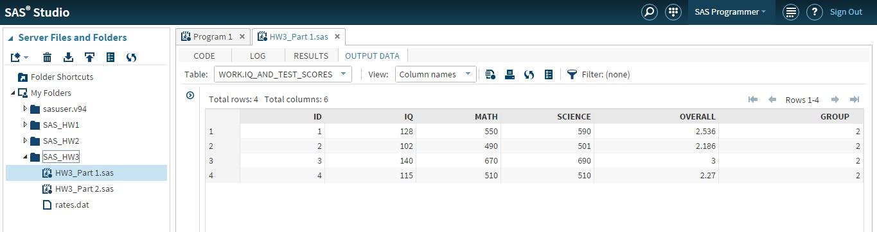

b) List data set in order of IQ

Code /*Part b*/

proc sort data=iq_and_test_scores out=iq_Sorted; by IQ; run;

Output Data

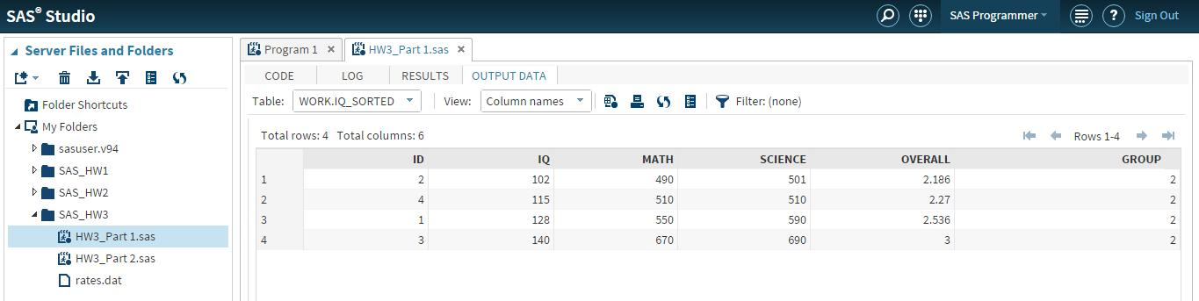

c) Frequencies for GROUP

Code /*Part C*/

proc freq data = iq_and_test_scores;

tables GROUP/Out=IQ_Scores_Frequency nocol norow nocum nopercent; run;

Output Data

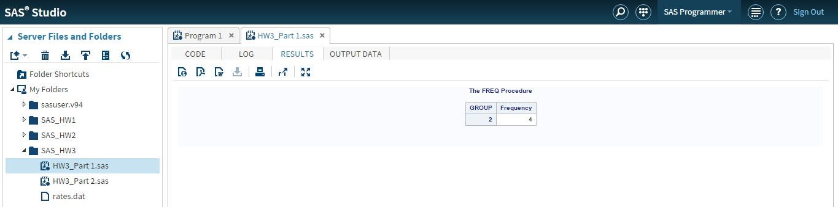

Problem 1.8 - Create a SAS program to calculate the BONUS and NEW_SALARY

Input

137 28000 1

214 98000 3

199 150000 3

355 57000 2

Code

/* Problem 1.8 */ Data emp_salary;

input EMPID SALARY JCLASS;

If Jclass = 1 then BONUS = 0.1*SALARY;

Else If Jclass = 2 then BONUS = 0.15*SALARY; Else BONUS = 0.2*SALARY;

NEW_SALARY = SALARY + BONUS; Datalines;

137 28000 1

214 98000 3

199 150000 3

355 57000 2;

Output Data

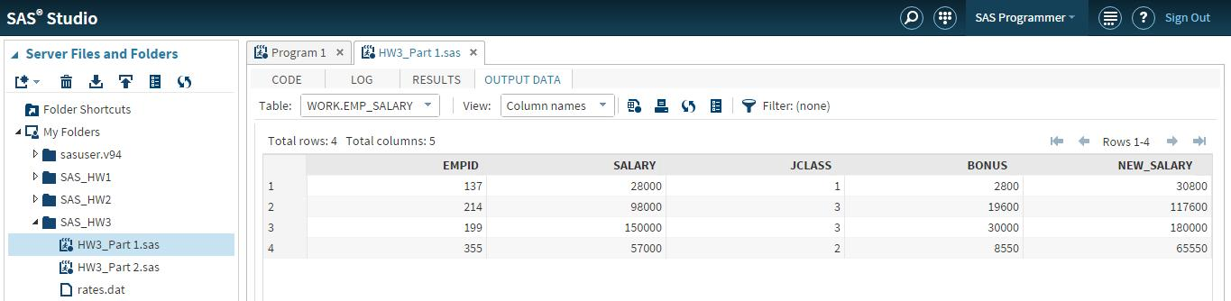

To print the details:

proc print data=emp_salary; title "Employee_Bonus Details"; run;

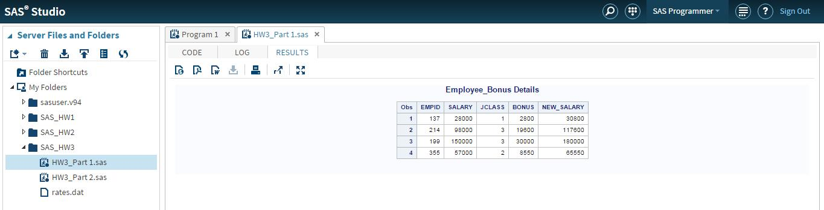

Problem 12.8 – Write a SAS data step to read lines of data and create a temporary SAS data set

Input

***Header line: ID GENDER DOB SCORE1 SCORE2 001 M 10/10/1976 100 99

002 F 01/01/1960 89

003 M 05/07/2001 90 98

Code

/*Problem 12.8*/ data prob12_8;

infile datalines delimiter='20'x dsd missover firstobs=2; input id_number $

gender $

dob :mmddyy. score1 score2;

format dob date9.; datalines;

***Header line: ID GENDER DOB SCORE1 SCORE2 001 M 10/10/1976 100 99

002 F 01/01/1960 89

003 M 05/07/2001 90 98

;

Output

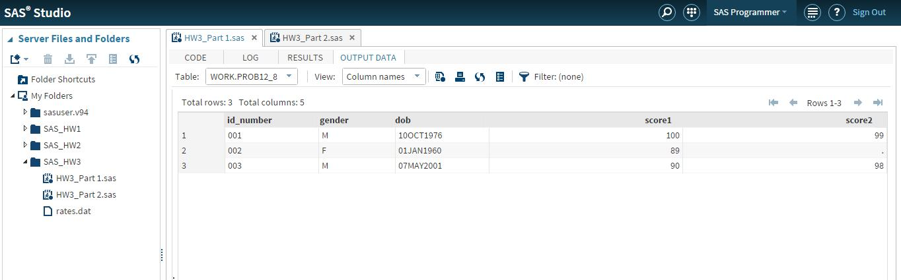

Problem 12.16 – SAS data set to read the given data

Input

001,M,06/14/1944

68,155

002,F,12/25/1967

52,99

003,M,07/04/1983

72,128

Code

/*Problem 12.16*/ data read_multi_line;

infile datalines delimiter=',';

input #1 id gender $ dob :mmddyy. #2 height weight; cards;

001,M,06/14/1944

68,155

002,F,12/25/1967

52,99

003,M,07/04/1983

72,128

;

run;

Output

